*A website that makes it easier to form groups and find people to study with*

*Software Grokkers*

Project Portfolio

*05/04/21*

Introduction Error! Bookmark not defined.

The Software grokkers Team 2

System Requirements 3

Epics 3

Epic #1 3

User Stories 3

User Story #1 3

Project Management 3

Continuity of Operations Plan (COOP) 3

Project Plan 0

System Architecture Design and Development <Milestone 2: Architecture> 0

System Implementation <Milestone 2: Architecture & Milestone 3: System Implementation> 0

Project Postmortem <Postmortem> 0

Project Wins 0

Root Cause Analysis 0

Lessons Learned 0

System Design 0

System Architecture <Milestone #2: System Architecture> 0

Component Design 0

Data Flow 0

System Components <Milestone 3: System Implementation> 0

Component [Component Name 1] 0

Component [Component Name 2] 0

Component [Component Name n] 0

Design Pattern <Milestone 3: System Implementation> 1

Design Pattern <Milestone 3: System Implementation> 1

[Project portfolio template directives and placeholders (delineated by “[ ]” or “< >” and/or highlighted or optional sections not included) should be removed from the document prior to submission. Empty sections for inclusion in later submissions may remain in the document for early submissions.]

[IMPORTANT: All diagrams developed using Enterprise Architectures must include the following acknowledgement: “Thanks to SPARX Systems for LSU student and faculty use of Enterprise Architect for academic purposes”.]

# Introduction

Finding partners to study for a course can be very difficult. Our website, Team Up, allows you to search for other people who are in the same classes, and are also committed to studying better. This service allows you to sort based on time and location so you can find the best partner possible. People can notify and communicate with each other using a chat room, so they can ask if they want to work together or figure out a time and place where they can meet up. We would also like to add features that will allow you to find people who are interested in the same activities.

With the help of JavaScript and MongoDB, we will be able to provide fast service to our users. We will also use HTML and CSS to design web pages with fluid animations and great user experience.

   

Core Features:

* Search for students who are in the same class
* Sort by time to find people that are available when you are
* Send notifications to people so they can invite you to their group. Ex: A person who wants to join a math group can send a notification to everyone who is already in the math group

Viable Features:

* Adding features for other activities, such as sports, eSports, etc.
* Sort by location so you can be partners with people that live nearby
* Implement a chat room that allows you to communicate with your study partner.

Stretch Features

* Integrate with Moodle to get a list of students and add them to a class group chat automatically
* Adding a feature that allows you to find a tutor in a course of your choice.

# The Software Grokkers Team

Tomi – Database, Backend. Focus on backend and implementing user database.

Ruchit – Database, Frontend. Focus on front end and web design

Geoffrey – Database, Frontend. Focus on front end and web design

Parimal – Algorithms. Responsible for searching algorithm

Kathan – Algorithms. Responsible for sorting algorithms

Chazz – Algorithms. Responsible for sorting algorithms

# System Requirements

## Epics

### Epic #1

*As a hobbyist, I want to find someone with a similar hobby, so I can improve my skills and grow in that field.*

## User Stories

### User Story #1

*As a student, I want to find someone to study with, so I can study better and pass my classes.*

### User Story #2

*As a football player, I want to find someone to play with, so I can have fun and improve my skills.*

# Project Management

## Continuity of Operations Plan (COOP)

Under normal circumstances team members will meet in person every week at a place discussed in the group chat. If any team member is not able to attend the in-person meeting, they must inform the team, and they have the option to still attend the meeting and communicate with everyone through zoom. The zoom meeting will be hosted by someone who is meeting in-person.

If a team member is unable to work on the project for any personal reasons, another team member with similar responsibilities can take over the position. If this person is also busy or cannot complete this task on their own, the work will be split across everyone in the team. In case of conflict there will be an official team meeting to discuss the subject matter.

## Project Plan

### System Architecture Design and Development

|  |  |  |  |  |  |  |  |  |
| --- | --- | --- | --- | --- | --- | --- | --- | --- |
| **#** | **Activity** | **Pre #** | **Estimated**  **Effort** | **Actual**  **Effort** | **Estimated**  **Start Date** | **Estimated**  **Finish Date** | **Actual**  **Start Date** | **Actual**  **Finish Date** |
| 1 | Design rough sign-up page |  | 8 | 5 | 2/8/22 | 2/10/22 | 2/13/22 | 2/17/22 |
| 2 | Design log in page | 1 | 8 | 4 | 2/11/22 | 2/13/22 | 2/17/22 | 2/19/22 |
| 3 | Write pseudocode for algorithms | N/A | 8 | 12 | 2/12/22 | 2/14/22 | 2/12/22 | 2/16/22 |
| 4 | Create fake users | N/A | 3 | 2 | 2/17/22 | 2/18/22 | 2/10/22 | 2/10/22 |
| 5 | Make a list of activities too show new user at login | 2 | 2 | 2 | 2/15/22 | 2/15/22 | 2/16/22 | 2/16/22 |
| 6 | Design backend | 2 | 2 | 8 | 2/16/22 | 2/16/22 | 2/19/22 | 2/21/22 |
| 7 | Decide what database technology to use | N/A | 1 | 1 | 2/17/22 | 2/17/22 | 2/17/22 | 2/17/22 |
| 8 | Discuss visuals and features to add to front end | 2 | 7 | 3 | 2/19/22 | 2/22/22 | 2/19/22 | 2/21/22 |

### System Implementation <Milestone 2: Architecture & Milestone 3: System Implementation>

Milestone 3 (System Implementation): The WBS activity chart for the milestone should be updated to include actual level of effort and start and completion dates.]

|  |  |  |  |  |  |  |  |  |
| --- | --- | --- | --- | --- | --- | --- | --- | --- |
| **#** | **Activity** | **Pre #** | **Estimated**  **Effort** | **Actual**  **Effort** | **Estimated**  **Start Date** | **Estimated**  **Finish Date** | **Actual**  **Start Date** | **Actual**  **Finish Date** |
| 1 | Finish designing log in and sign-up page |  | 10 |  | 2/25/22 | 2/28/22 |  |  |
| 2 | Connect database to log-in, sign-up page and add fake users | 1 | 15 |  | 2/27/22 | 03/4/22 |  |  |
| 3 | Design Home Page | 1 | 12 |  | 3/2/22 | 3/6/22 |  |  |
| 4 | Allow users to create groups and connect it to database | 3 | 8 |  | 3/7/22 | 3/9/22 |  |  |
| 5 | Implement search algorithms that allow users to search for certain groups | 4 | 16 |  | 3/10/22 | 3/15/22 |  |  |
| 6 | Implement location and time sorting algorithms | 5 | 22 |  | 3/15/22 | 3/21/22 |  |  |
| 7 | Enable notification feature in groups | 4 | 8 |  | 3/21/22 | 3/24/22 |  |  |
| 8 | Work on private and group chat rooms | 4 | 20 |  | 3/24/22 | 4/1/22 |  |  |
| 9 | Fix any bugs and make sure website runs smoothly | 8 | 15 |  | 4/1//22 | 04/07/22 |  |  |
| 10 | Integrate with Moodle (if time permits) | 9 | 12 |  | 4/1/22 | 4/07/22 |  |  |

## Project Postmortem <Postmortem>

### Project Wins

[Provide a bulleted list of at least 3 positive aspects of the project.]

### Root Cause Analysis

[Provide a bulleted list of at least 3 negative aspects of the project. For each negative, provide the answer to the three successive “Why” questions. ]

### Lessons Learned

[For each negative aspect identified in the Root Cause Analysis, provide a mitigation strategy (i.e., what process should be introduced) to ensure that the problem is not repeated in subsequent projects.]

# System Design

[*Include a short (1-2 sentences) statement about system design*.]

* System design helps plan what components will be in included in the project before implementation.

## System Architecture <Milestone #2: System Architecture>

[*A short description of the system architecture.*]

* The system architecture contains components that show the classes, functions and their relationships. The user interacts with the view which displays data retrieved from several connected components. The user will be able to interact with other components after they have logged in or signed up on the website. Data from the user is stored in an external database. This data can be retrieved, and used by other classes, functions or components.

### Component Design

[*Insert image of system architecture component diagram.*]

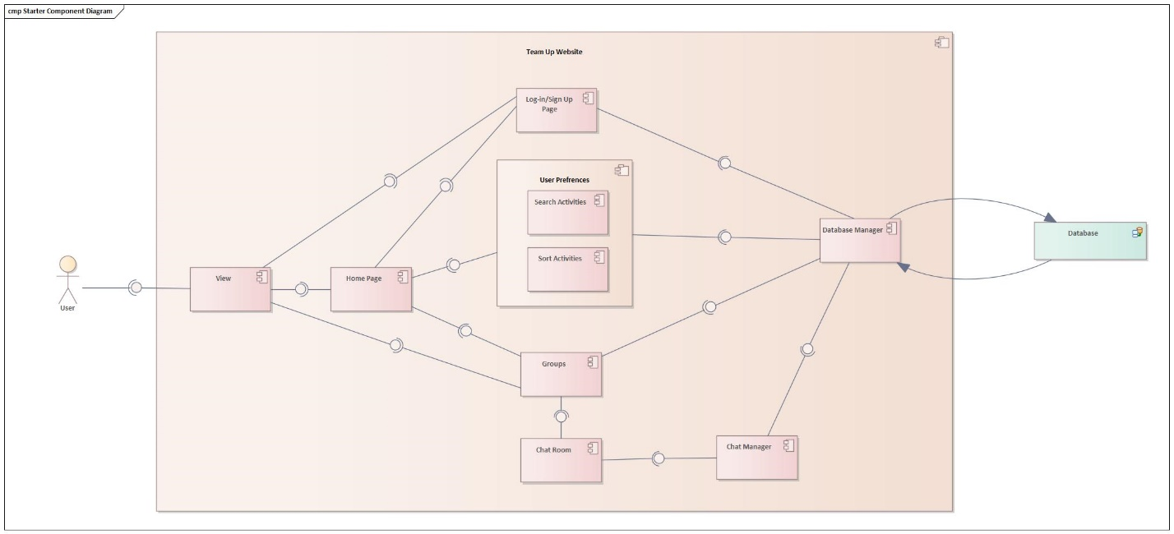

[*Architecture overview, to include user I/O, external data sources, and major system components.*]

The diagram shows all components of the website. The user interacts with the website through the view, which displays the home, login/sign-up, or group page. Components such as Homepage, Login/Signup, Groups and Chat room are webpages which can be seen by the user. Components such as Search Activities, Sort Activities, Database Manager and Chat Manager are classes and functions which are not visible to the user. The database is used to store user data, information can be entered and retrieved using the database manager component.

### Data Flow

[*Insert image of system architecture data flow diagram.*]

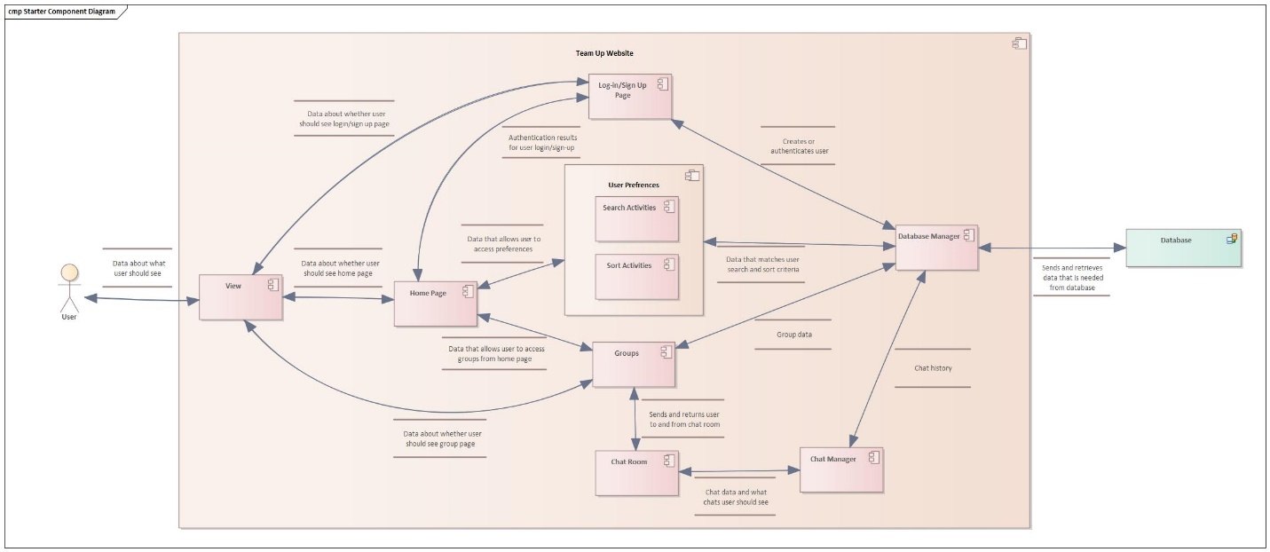

[*Architecture data flow discussion: a high-level description of the data between both internal major components and external data sources.*]

After the user enters their log in or sign up details, the data is sent to the database for authentication. If the user is authenticated, they will be sent to the homepage. The user can then access other components.

## System Components <Milestone 3: System Implementation>

[*Include a component sub-section for each component in the architecture diagram. Each component subsection will include a class diagram*]

### Component [Component Name 1]

[*A short description of the component*.]

[*An EA class diagram of the component that includes method parameters.*]

### Component [Component Name 2]

[*A short description of the component*.]

[*An EA class diagram of the component that includes method parameters.*]

### Component [Component Name n]

[*A short description of the component*.]

[*An EA class diagram of the component that includes method parameters.*]

## Design Pattern <Milestone 3: System Implementation>

[*Class diagram of design pattern incorporated into the project. Pattern must be specific to the project and not a general design pattern class diagram. The project must include at least 2 design patterns covered in class.*]

## Design Pattern <Milestone 3: System Implementation>

[*Class diagram of design pattern incorporated into the project. Pattern must be specific to the project and not a general design pattern class diagram. The project must include at least 2 design patterns covered in class.*]